“How do I check the status of my order?”
To look up the status of your Purchase Order (PO), use Mckesson’s Purchasing application by following the steps below:
- Click on your Windows Start icon:
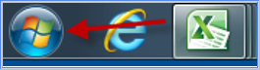
- In “Search programs and files” type Purchasing
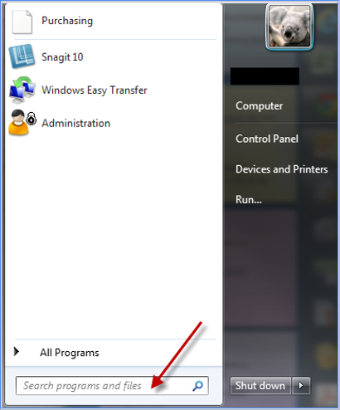
Purchasing application can also found under Windows Start > All Programs > McKesson Supply Chain Management > Purchasing.
Tip: You may drag the application onto your Desktop or “Pin” the program to your taskbar for quicker access in the future.
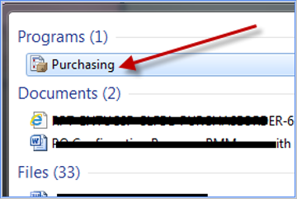
Opening the Purchasing application should bring up the Purchase Order Selection pop-up window:
- Click on the “Query” tab.
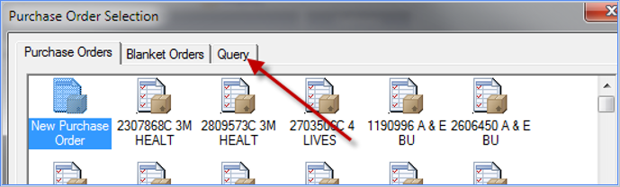

- In the “Where field” select “Requisition Number” or “P.O. Number” in the dropdown menu, based on the criteria for which you wish to search.
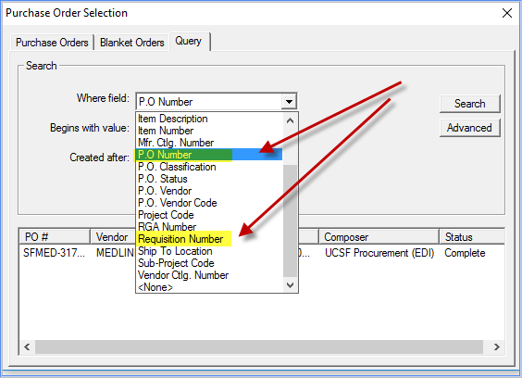
- Enter the Requisition # or PO # in the field “Begins with value”
In this example, Requisition 4000397 is entered in the “Begins with value” field.
Important: Search field is character and case sensitive! Be sure to delete any spaces after the number and leave the “Created after” field blank.
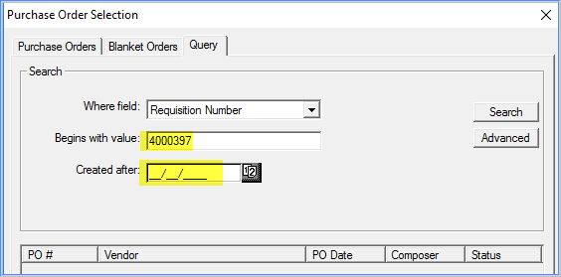
- Click “Search”
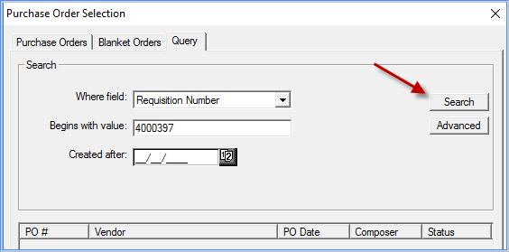

Search results will show:
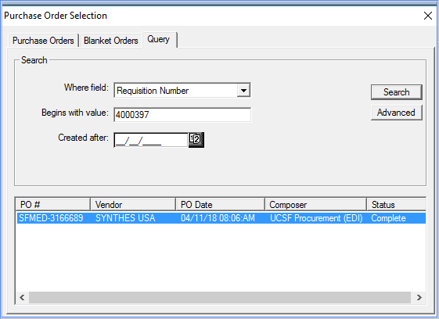
The “Composer” column identifies which Buyer processed the PO. The Composer is the first person to contact for any inquiries about your order.
Note: If you see “UCSF Procurement (EDI)” as Composer, please contact a Buyer for more information. Click here for the list of Buyers https://www.supplychain-ucsfhealth.org/transactions
The “Status” column identifies status of a PO.
PO Statuses and their definitions:
- “Complete” – All line items on your PO have been received - Contact Receiving dept. instead of Purchasing dept.
- “Partial” – Some of the Line Items on your PO have been received
- “On Order” – No items on your PO have been received (order may be in transit)
- “Draft” – Your PO is under review by the Purchasing dept. and has not been sent to the vendor
- “Killed” – Your PO has been cancelled/rejected

- Double-click on the order line to open your PO and check if there are additional notes.
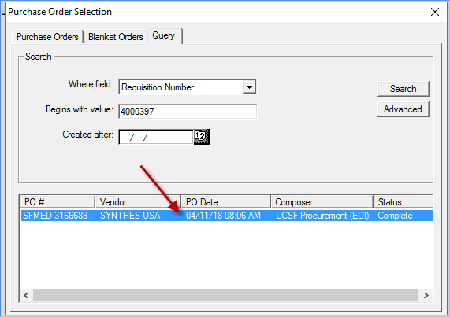

- Click on the Header icon if there is additional information on your order
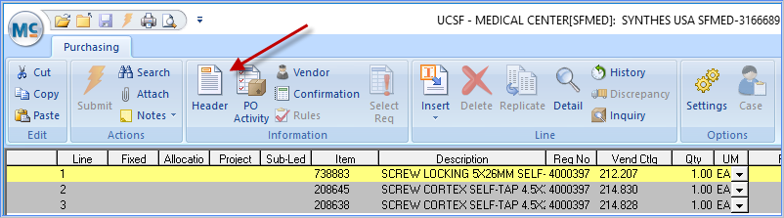
In the example below, the Buyer has entered notes about the order, such as a confirmation number (1464413) and estimated delivery date (10/5/16).
